# From weather forecasting to climate modelling using OpenIFS

https://www.ecmwf.int/en/newsletter/164/meteorology/weather-forecasting-climate-modelling-using-openifs

**Joakim Kjellsson (GEOMAR and University of Kiel, Germany)**

**Jan Streffing (AWI, Germany)**

**Glenn Carver**

**Marcus Köhler (both ECMWF)**

[Share](https://www.addtoany.com/share#url=https%3A%2F%2Fwww.ecmwf.int%2Fen%2Fnewsletter%2F164%2Fmeteorology%2Fweather-forecasting-climate-modelling-using-openifs&title=From%20weather%20forecasting%20to%20climate%20modelling%20using%20OpenIFS)

**Current activities at the GEOMAR Helmholtz Centre for Ocean Research in Kiel and the Alfred Wegener Institute, Helmholtz Centre for Polar and Marine Research (AWI) in Bremerhaven, Germany, include developing two new versions of high-resolution coupled climate models. Both climate models successfully use OpenIFS, a portable version of ECMWF’s Integrated Forecasting System (IFS) for use at universities and research institutes. The experience gained in using OpenIFS for climate modelling can in turn provide insights that will help ECMWF to further develop the IFS.**

Benefits of using OpenIFS​

It is becoming increasingly clear that high horizontal resolution can be very beneficial for coupled climate models. Experiments with the ECMWF forecasting system and as part of the high-resolution climate model intercomparison project, HighResMIP, have shown that increasing the horizontal resolution in a coupled climate model reduces biases, improves the representation of air–sea interactions, and enhances predictability. In addition, increased horizontal resolution in the atmospheric model can improve orographic drag, which in turn can reduce biases in the jet stream position, blocking and storm tracks.

GEOMAR and AWI are both known for developing and running eddy-rich ocean-only models with high horizontal resolution using grid refinement. At AWI, the FESOM2 ocean model employs an unstructured mesh, where the horizontal resolution is spatially variable depending on, for example, sea-surface height variance, local Rossby radius etc. At GEOMAR, the NEMO ocean model uses a grid refinement tool, AGRIF, to refine the mesh in specific basins, e.g. the North Atlantic or the South Atlantic/ Western Indian Ocean. Both institutes have built coupled climate models using their respective eddy-rich ocean models coupled to the ECHAM6 atmospheric model: FOCI at GEOMAR (Matthes et al., 2020) and AWI-CM at AWI (Sidorenko et al., 2015). These coupled models will be used in a variety of projects in the future. However, ECHAM is no longer actively developed and has poor computational efficiency when running at higher horizontal resolutions than ~0.5°. The institutes have therefore developed new versions of FOCI and AWI-CM which use the ECMWF OpenIFS atmospheric model (Figure 1). This comes with a number of benefits.

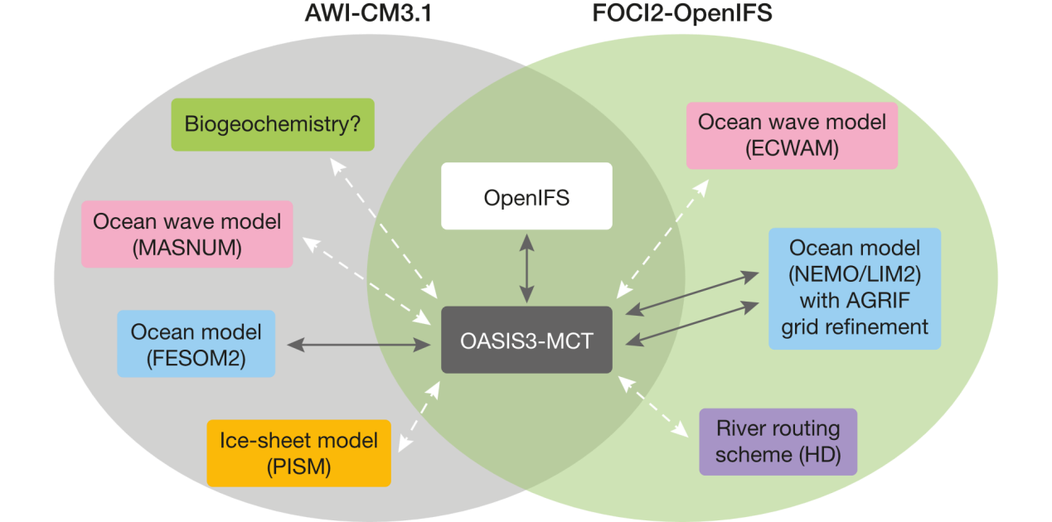

**FIGURE 1** Schematic of the AWI-CM3.1 (grey circle) and FOCI2-OpenIFS (green circle) coupled climate models from AWI and GEOMAR, respectively. Both use the OpenIFS atmospheric model and the OASIS3-MCT coupler. Dark lines show couplings to components currently in use, while light dashed lines show couplings planned for future versions. Note that AGRIF is embedded within the NEMO executable but has its own coupling to OASIS3-MCT.

First, the OpenIFS model is well suited to run at both low and high horizontal resolutions. As an example, a simulation with ECHAM6 with 95 vertical levels and a horizontal resolution of 1.875° (209 km grid spacing at the equator) running on 600 cores runs at about the same speed as OpenIFS (IFS Cycle 40r1) with 91 vertical levels and a horizontal resolution of 1.125° (125 km) on 280 cores, i.e. OpenIFS runs at less than half the computational cost at higher spectral and grid-point resolutions. The ability to run OpenIFS at higher atmospheric resolutions therefore enables scientists at GEOMAR and AWI to make full use of their high-resolution ocean models in the coupled climate models they run.

Second, the OpenIFS model has an active and growing user community and a small support team at ECMWF who are able to assist when configuring atmosphereonly and coupled simulations.

Third, the OpenIFS model includes much of the worldleading science provided by ECMWF’s IFS in a portable atmosphere–land–wave model. The addition of interfaces to the OASIS coupler allows it to be integrated into existing modelling frameworks.

Fourth, joining the OpenIFS community strengthens the collaborations between AWI, GEOMAR, the EC-Earth consortium and ECMWF, which has proven beneficial for all parties.

OpenIFS for climate modelling

The IFS has already been used for climate modelling purposes both as part of the EC-Earth model and by ECMWF scientists for the EU-funded PRIMAVERA project (Roberts et al., 2018), while the closely related ARPEGE-Climat is used in the French National Centre for Meteorological Research (CNRM) climate model (Table 1). Now AWI and GEOMAR have jointly adapted the OpenIFS model for climate integrations with contributions from the EC-Earth community. In addition, the EC-Earth model version 4 will also use OpenIFS, although this is very much at a prototype stage. The modifications to OpenIFS by AWI and GEOMAR include adding interfaces for the OASIS3-MCT coupler; a river-routing scheme; and forcings from the World Climate Research Programme’s Coupled Model Intercomparison Project (CMIP5 and CMIP6) as well as orbital forcing parameters for paleoclimate simulations. The OASIS development team contributed to the development of the OASIS interfaces in the OpenIFS model with dedicated support from the EU-funded IS-ENES3 (Infrastructure for the European Network for Earth System Modelling) project.

The AWI and GEOMAR models with OpenIFS – AWICM3.1 and FOCI2-OpenIFS respectively – use the same workflow manager, ESM-Tools (Barbi et al., 2020), to manage the simulations, e.g. compiling the model, linking forcing data, restarting the model, post-processing output data etc. The ESM-Tools have been developed by the Helmholtz ESM project. They are publicly available and make it easier for new OpenIFS users to get started with atmosphere-only and coupled simulations.

The OpenIFS developments at AWI and GEOMAR started with OpenIFS 40r1 in late 2017, and both institutes are now integrating OpenIFS 43r3 into their respective coupled models. The second release of OpenIFS 43r3 from ECMWF will include coupling interfaces to the sea ice–ocean models FESOM2 and NEMO/AGRIF. This will enable other licensed OpenIFS users to benefit from the developments at AWI and GEOMAR. Examples include the ongoing development of EC-Earth version 4 as well as new coupled climate models using OpenIFS in Italy and China. The joint development of the OpenIFS model for coupled climate modelling has also led to closer scientific collaboration between AWI, GEOMAR, the OpenIFS support team at ECMWF and the EC-Earth community as well as participation from all partners at the annual OpenIFS workshop and visits to ECMWF.

|  |  |  |  |
| --- | --- | --- | --- |
|  | **ECMWF-IFS climate configuration (PRIMAVERA project)** | **EC-Earth v3** | **CNRM-CM6** |
| **Atm** | IFS Cycle 43r1 | Based on IFS Cycle 36r4 | ARPEGEClimat v6 |
| **Ocean** | NEMO v3.4 | NEMO v3.6 | NEMO v3.6 |
| **Coupler** | Single executable | OASIS3-MCT3 | OASIS3-MCT3 |
| **Horizontal res. Atm/Ocean** | ​1° / 1°  0.25° / 0.25° | ​0.7° / 1°  0.35° / 0.25° | 1.4° / 1° |
| **Grid refinement** | No | No | No |
| **Scope (realised/ planned)** | AOGCM/AOGCM | ESM/ESM | AOGCM/ AOGCM |

|  |  |  |  |
| --- | --- | --- | --- |
|  | **FOCI2 (OpenIFS)** | **AWI-CM3.1** | **EC-Earth v4** |
| **Atm** | OpenIFS 43r3 | OpenIFS 43r3 | OpenIFS 43r3 |
| **Ocean** | NEMO v3.6 | FESOM2 | NEMO v4 |
| **Coupler** | OASIS3-MCT4 | OASIS3-MCT4 | OASIS3-MCT4 |
| **Horizontal res. Atm/Ocean** | 1.1° / 0.5°  ​0.23° / [0.5°, 0.1°] | 0.56° / [1°, 0.2°]  0.28° / [0.6°, 0.1°] | TBD |
| **Grid refinement** | AGRIF | Unstructured grid | No |
| **Scope (realised/ planned)** | AOGCM/AOGCM | AOGCM/ESM | AOGCM/ESM |

**TABLE 1**​Overview of the use of versions of the IFS, OpenIFS and the closely related ARPEGE model from Météo-France in current climate models. The scope denotes whether the model is/will be an Atmosphere–Ocean General Circulation Model (AOGCM) or a full Earth System Model (also including a biogeochemical model, dynamic vegetation and atmospheric chemistry). The ECMWF-IFS climate configuration is essentially an AOGCM but without river routing.

Model frameworks and early results

GEOMAR has set up configurations of FOCI2 with OpenIFS at low or high horizontal resolution for the atmosphere, coupled to NEMO with optional grid refinement with AGRIF. In the near future, FOCI2 will include coupling between NEMO and ECMWF’s ECWAM ocean wave model and it will couple OpenIFS to the HD river routing scheme developed by Helmholtz Centre Geesthacht. AWI has developed AWI-CM3.1, which comprises OpenIFS at low or high horizontal resolution for the atmosphere, coupled to FESOM2 with the COREII (100–20 km) or HR (60–10 km) unstructured meshes (see Table 1). Long-term perspectives include ice-sheet and atmosphere–wave–ocean coupling with the PISM ice-sheet model and the MASNUM ocean wave model, respectively. Future developments of AWI-CM3.1 will be closely synchronised with EC-Earth version 4 and will therefore have ESM capabilities.

Atmospheric models forced with high-resolution seasurface temperature data show a band of convergent surface winds and precipitation over the Gulf Stream. At the same time, climate models with a high-resolution ocean show that increasing the atmospheric resolution results in stronger eddy potential energy dissipation leading to stronger western boundary currents. This suggests that oceanic mesoscale eddy activity strongly influences atmospheric motions locally through air–sea fluxes of momentum, heat and freshwater. However, in most climate models the air–sea fluxes are calculated in the atmospheric model. This means that both the atmosphere and the ocean must have sufficiently high horizontal resolution for the oceanic mesoscale to influence the atmosphere. Hence, using an eddyresolving ocean model of ~0.1° resolution coupled to a coarse-resolution atmosphere of ~2° resolution improves ocean dynamics and reduces surface biases, but the impact on the atmosphere will likely be underestimated.

Figure 2 demonstrates the capabilities of FOCI2 and AWICM3.1 by showing results from five years of simulation. Both models have comparable high-resolution atmosphere and ocean grids. The FOCI2 simulation has a 0.23° atmospheric resolution with a 0.5° ocean resolution with a grid refinement down to 0.1° in the North Atlantic. AWI‑CM3.1 has a 0.28° atmospheric resolution with an unstructured ocean grid where horizontal resolution varies between 10 and 60 km and is finest where seasurface height variance is largest. We have calculated the mean wintertime surface kinetic energy using daily output from AWI‑CM3.1 and five-daily output from FOCI2. Both models exhibit an eddy-rich and energetic Gulf Stream and North Atlantic Current, indicating that the oceanic horizontal resolution is sufficient to resolve the baroclinic instabilities and eddy-mean flow interactions in the region. The Gulf Stream detaches slightly further north in FOCI2 compared to AWI‑CM3.1. This could be the result of a coarser effective resolution in FOCI2. In the atmosphere, both models show a band of high precipitation anchored over the Gulf Stream, which is a clear signal that the oceanic mesoscale activity is felt by the atmosphere. Both AWI and GEOMAR are currently extending these simulations to span up to a century. They are also carrying out experiments using a low-resolution atmosphere to evaluate the impact of the high-resolution atmosphere on mean state and climate variability in climate models.

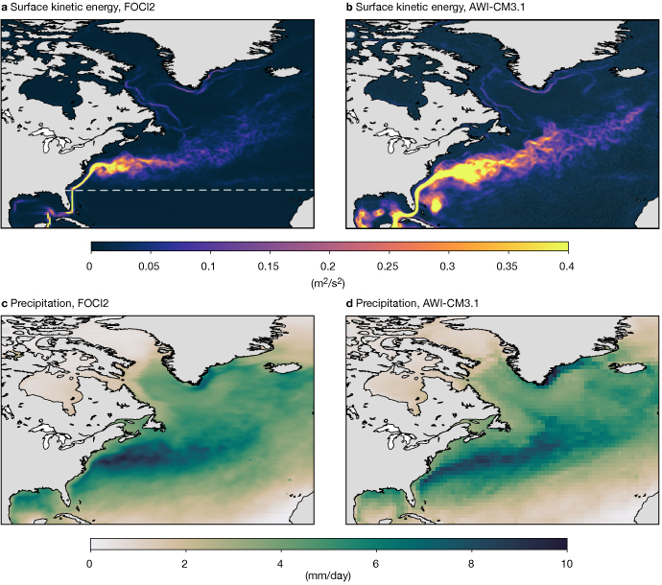

**FIGURE 2** The charts show mean December–January–February values for (a) surface kinetic energy from FOCI2, (b) surface kinetic energy from AWI-CM3.1, (c) precipitation from FOCI2 and (d) precipitation from AWI-CM3.1. Kinetic energy is calculated from daily means in AWI-CM3.1 and five-daily means in FOCI. For FOCI2, the grid refinement is north of the white dashed line. Note that the resolution is 0.28° in AWI-CM3.1 but the output is coarse-grained to 1° resolution.

Benefits for weather forecasting

The results from climate modelling using OpenIFS can provide insights that will help ECMWF to evaluate the representation of coupled Earth system processes in the IFS and identify model biases. An accurate representation of such processes is particularly important at medium-range to seasonal timescales. With increasing lead time, weather forecasts tend towards the model climate, which should therefore be as realistic as possible. The asymptotic behaviour of the coupled model is also important for the development of coupled approaches to data assimilation and reanalysis. The results obtained when coupling the atmospheric and land components of the IFS to NEMO using grid-refinement or a different ocean model entirely (FESOM2) will also usefully complement the insights gained from the IFS climate configuration experiments carried out in the PRIMAVERA project.

Outlook

The OpenIFS model already is and will continue to be an important component for climate modelling at AWI and GEOMAR. Both institutes plan to use their respective high-resolution climate models for various projects for years to come. The ability to run climate models efficiently at high resolution, the world-leading science in the IFS, and the integration of active atmospheric chemistry and parallel netCDF I/O (XIOS) make the OpenIFS a very attractive atmospheric model for climate modelling projects. Ongoing and future projects with FOCI2 include the following:

* studying the role of the oceanic mesoscale in driving atmospheric extreme events (the ROADMAP project, funded by JPI Oceans)
* heat uptake over the Southern Ocean (SO‑CHIC, an EU‑funded Horizon 2020 project)
* the impact of Greenland meltwater on North Atlantic climate (G‑shocx, funded by the German Research Foundation).

GEOMAR also plans to make coupled experiments with a global 0.25° ocean mesh and 0.05° refinement in the North Atlantic – an unprecedented resolution in coupled climate models. AWI-CM3.1 is earmarked for use in the second phase of the PalMod project (funded by the German Federal Ministry of Education and Research), which aims to study transient changes between glacial cycles. It will also be integrated into the Parallel Data Assimilation Framework (PDAF) developed at AWI. In addition, AWI has used OpenIFS to conduct atmosphere-only simulations for the World Climate Research Programme’s Polar Amplification Model Intercomparison Project (PAMIP).

Integrating OpenIFS into the existing modelling systems at GEOMAR and AWI has made it possible to break new scientific ground by allowing the use of a variableresolution ocean mesh coupled to a high-resolution atmosphere. It has also led to new fruitful collaborations between AWI, GEOMAR, ECMWF and the EC-Earth consortium. ECMWF stands to benefit from those collaborations as the results of climate modelling using OpenIFS can provide useful pointers for model development at ECMWF.

The integration of OpenIFS into ESM-Tools makes it easier for new OpenIFS users to get started. Using OpenIFS in FOCI2 and AWI-CM3.1 would not have been possible without the support of the OpenIFS team at ECMWF and the EC-Earth team, and we look forward to more collaborations with the growing OpenIFS community in the future.

Further reading

**Barbi**, **D.**, **N. Wieters**, **P. Gierz**, **F. Chegini**, **S. Khosravi** & **L. Cristini**, 2020: ESM-Tools Version 4.0: A modular infrastructure for stand-alone and coupled Earth System Modelling (ESM). *Submitted to Geoscientific Model Development*.

**Matthes**, **K.**, **A. Biastoch**, **S. Wahl**, **J. Harlaß**, **T. Martin**, **T. Brücher et al.**, 2020: The Flexible Ocean and Climate Infrastructure Version 1 (FOCI1): Mean State and Variability, *Geosci. Model Dev.*, **13**, 2533–2568, doi:10.5194/gmd-13- 2533-2020.

**Roberts**, **C.D.**, **S. Keeley**, **F. Molteni**, **R. Senan**, & **Torben Königk**, 2018: Coordinated climate simulations using the IFS,*ECMWF Newsletter***No. 157**, 6–7.

**Sidorenko**, **D.**, **T. Rackow**, **T. Jung**, **T. Semmler**, **D. Barbi**, **S. Danilov et al.**, 2015: Towards multi-resolution global climate modelling with ECHAM6-FESOM. Part 1: model formulation and mean climate. *Clim. Dyn.*, **44**, doi:10.1007/ s00382-014-2290-6.